p
Celeste Dussan Ospina
[Dirección de correo electrónico]

parcial practico

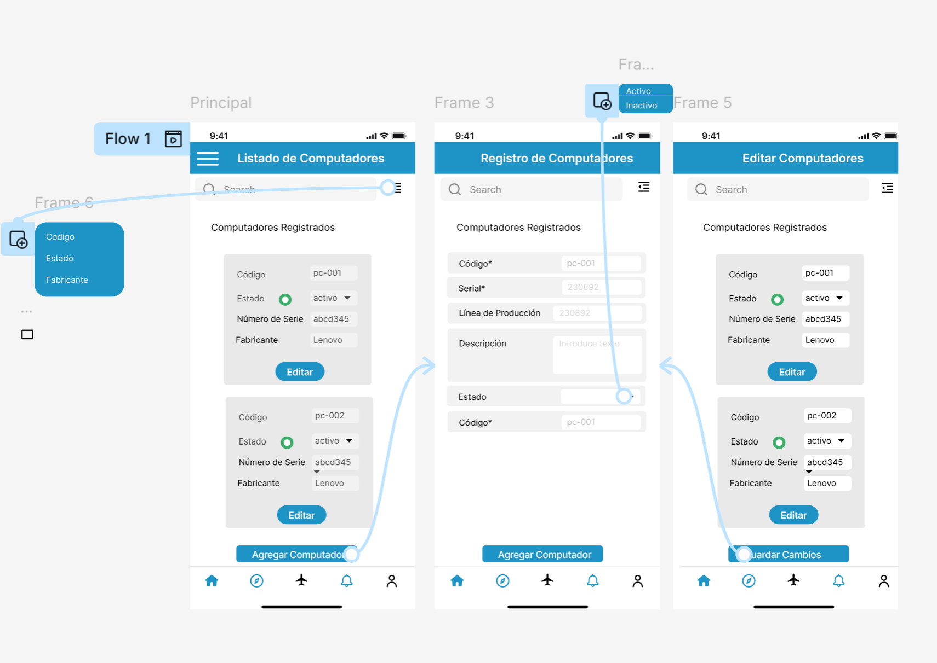
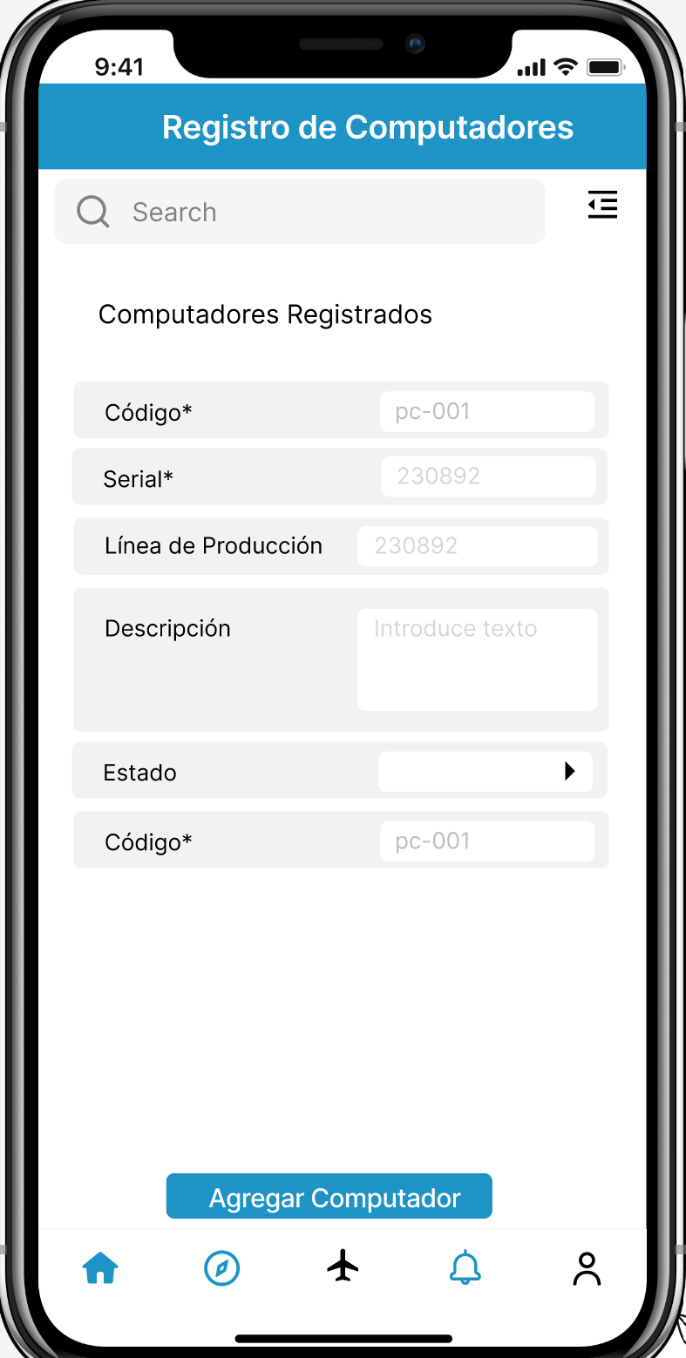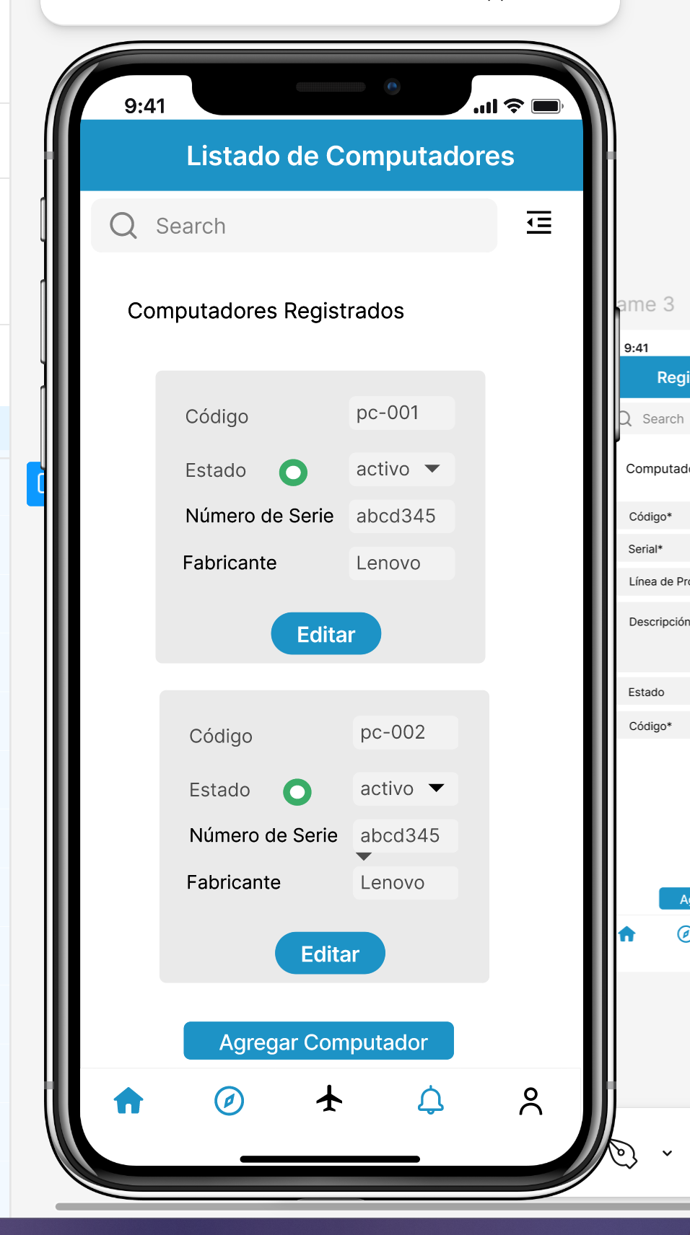

LINK FIGMA
https://www.figma.com/proto/OZCuZ7OwhcktP2SRCTgY96/Untitled?node-id=0-1&t=lKTSiW1DBQXamYFj-1

LINK GIT
https://github.com/CelesteDussan/programacion-movil-2025-a-g2/tree/feature/exam

